**DATA SCIENCE LAB 4**

**Roll no: 20K-0409**

**Screen Shots**

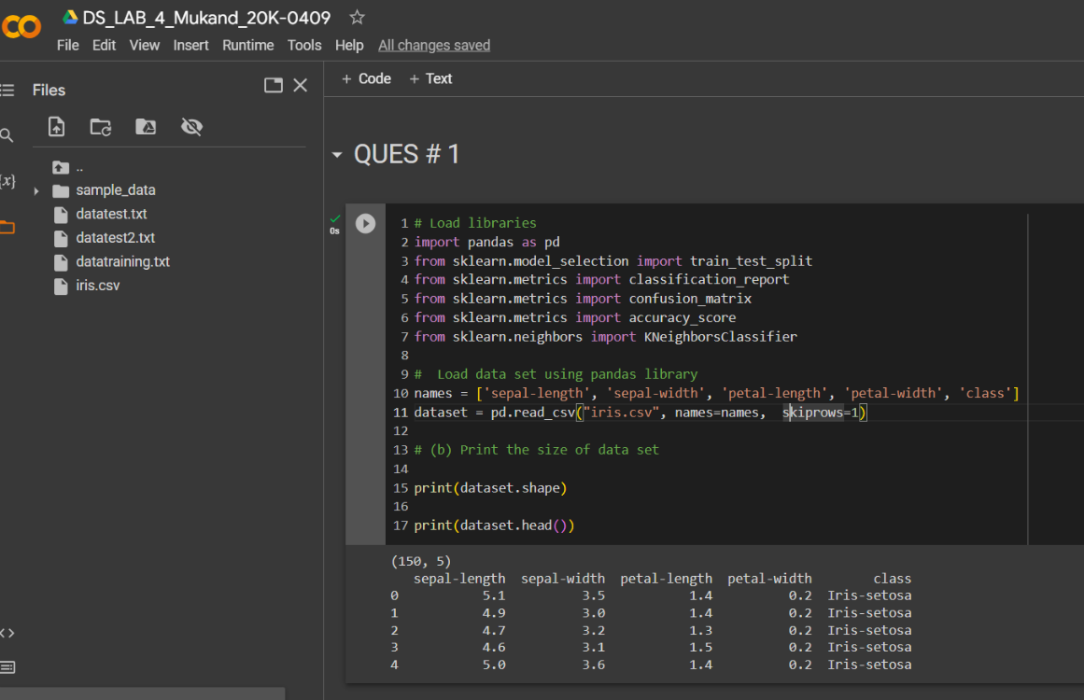**Ques # 1**

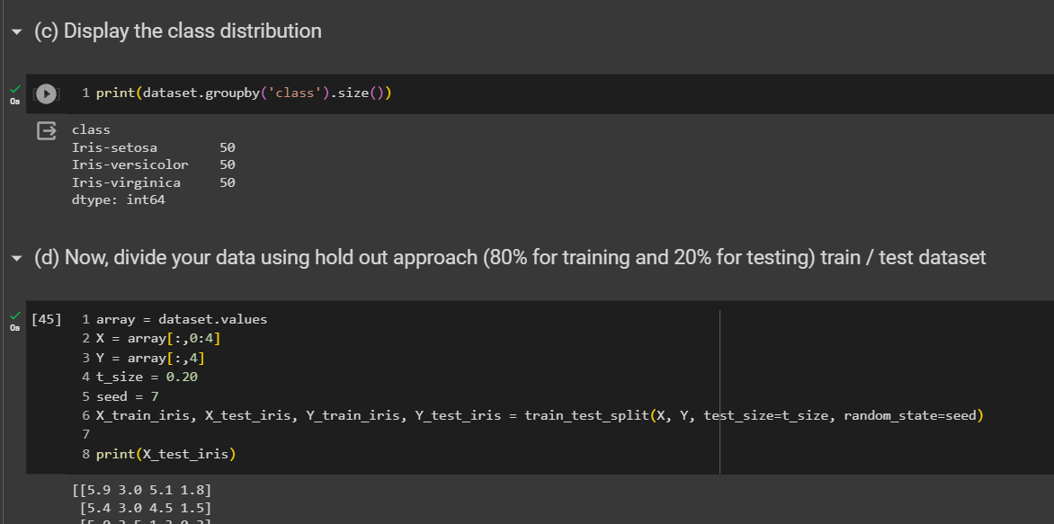

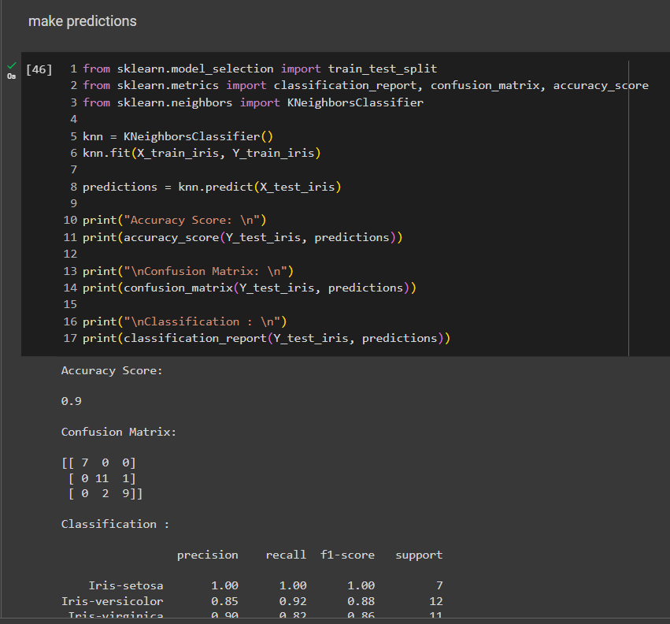

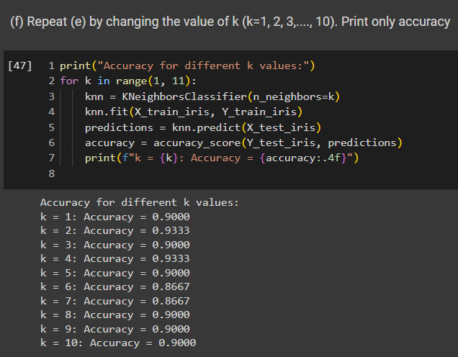

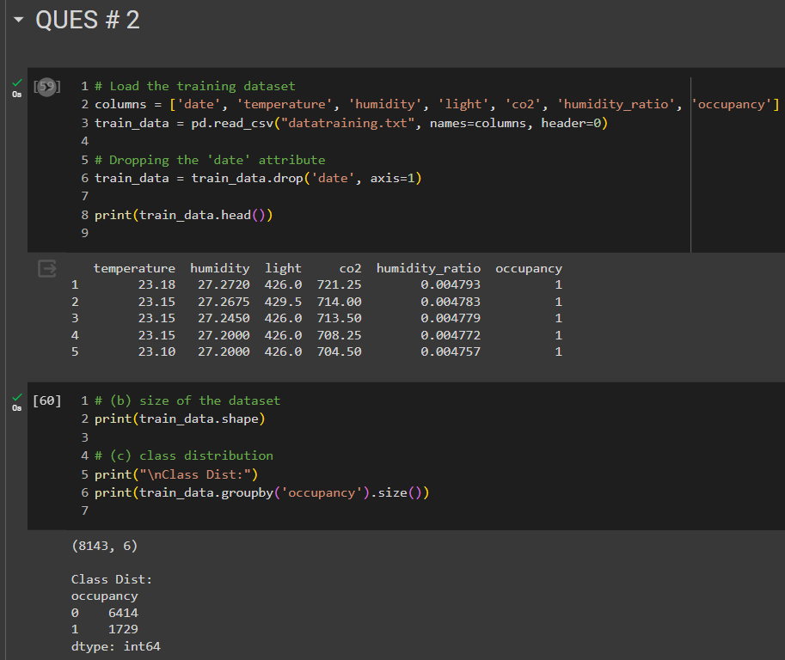**Ques # 2**

**Ques#3**

